JAVA Quiz: Week 3

1. Please try to explain the below concept in Spring Framework including

* Inversion of Control, 🡪
* Dependency injection 🡪
* Aspect-Oriented Programming 🡪 MVC + DDD

You need to prepare on follow question:

* What is the concept do in spring?
* Use case on the concept?
* How to use in coding?

Face to Face explain the concept when you submit the quiz. You may draft some diagram or ppt to explain (not necessary).

1. Follow below guide to create the Spring Boot Login with JWT.  
   <https://www.bezkoder.com/spring-boot-login-example-mysql/>

**Run & Check**

Run Spring Boot application with command: mvn spring-boot:run

Tables that we define in *models* package will be automatically generated in Database.  
If you check MySQL database for example, you can see things like this:

mysql> describe users;

+----------+--------------+------+-----+---------+----------------+

| Field | Type | Null | Key | Default | Extra |

+----------+--------------+------+-----+---------+----------------+

| id | bigint(20) | NO | PRI | NULL | auto_increment |

| email | varchar(50) | YES | UNI | NULL | |

| password | varchar(120) | YES | | NULL | |

| username | varchar(20) | YES | UNI | NULL | |

+----------+--------------+------+-----+---------+----------------+

4 rows in set (0.00 sec)

mysql> describe roles;

+-------+-------------+------+-----+---------+----------------+

| Field | Type | Null | Key | Default | Extra |

+-------+-------------+------+-----+---------+----------------+

| id | int(11) | NO | PRI | NULL | auto_increment |

| name | varchar(20) | YES | | NULL | |

+-------+-------------+------+-----+---------+----------------+

2 rows in set (0.00 sec)

mysql> describe user_roles;

+---------+------------+------+-----+---------+-------+

| Field | Type | Null | Key | Default | Extra |

+---------+------------+------+-----+---------+-------+

| user_id | bigint(20) | NO | PRI | NULL | |

| role_id | int(11) | NO | PRI | NULL | |

+---------+------------+------+-----+---------+-------+

2 rows in set (0.00 sec)

We also need to add some rows into **roles** table before assigning any role to User.  
Run following SQL insert statements:

INSERT INTO roles(name) VALUES('ROLE_USER');

INSERT INTO roles(name) VALUES('ROLE_MODERATOR');

INSERT INTO roles(name) VALUES('ROLE_ADMIN');

Then check the tables:

mysql> select * from roles;

+----+----------------+

| id | name |

+----+----------------+

| 1 | ROLE_USER |

| 2 | ROLE_MODERATOR |

| 3 | ROLE_ADMIN |

+----+----------------+

3 rows in set (0.00 sec)

Register some users with /signup API:

* **admin** with ROLE_ADMIN
* **mod** with ROLE_MODERATOR and ROLE_USER
* **zkoder** with ROLE_USER

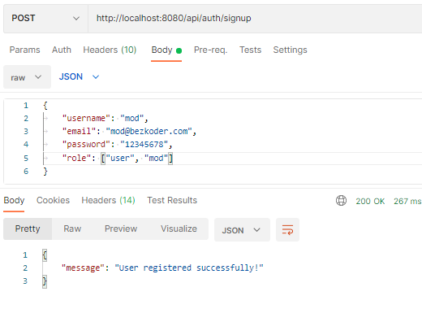

mysql> select * from users;

+----+--------------------+--------------------------------------------------------------+----------+

| id | email | password | username |

+----+--------------------+--------------------------------------------------------------+----------+

| 1 | admin@bezkoder.com | $2a$10$XEGS8J0hIUII6kdPgT9ykuRTwPCdDiDzt24eOcodgi16kTMQPfqna | admin |

| 2 | mod@bezkoder.com | $2a$10$jfLldGLZ0jTVRIt.mSqkxen.tHA3ynsr4.FWTZVM1rOp3STVLi8Ke | mod |

| 3 | user@bezkoder.com | $2a$10$IcQFF9tvJt/idNGejhbWMuh9voYXB15qTc7YXQNpLyuEyNE.oSxge | zkoder |

+----+--------------------+--------------------------------------------------------------+----------+

3 rows in set (0.00 sec)

mysql> select * from roles;

+----+----------------+

| id | name |

+----+----------------+

| 1 | ROLE_USER |

| 2 | ROLE_MODERATOR |

| 3 | ROLE_ADMIN |

+----+----------------+

3 rows in set (0.00 sec)

mysql> select * from user_roles;

+---------+---------+

| user_id | role_id |

+---------+---------+

| 2 | 1 |

| 3 | 1 |

| 2 | 2 |

| 1 | 3 |

+---------+---------+

4 rows in set (0.00 sec)

**Access public resource:** GET /api/test/all

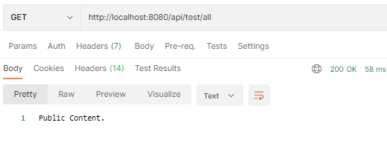

**Access protected resource without Login:** GET /api/test/user

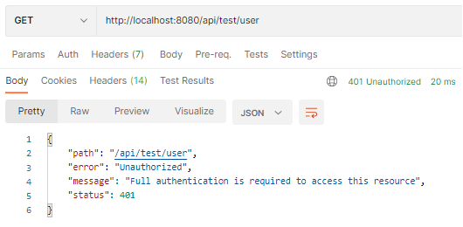

**Login an account:** POST /api/auth/signin

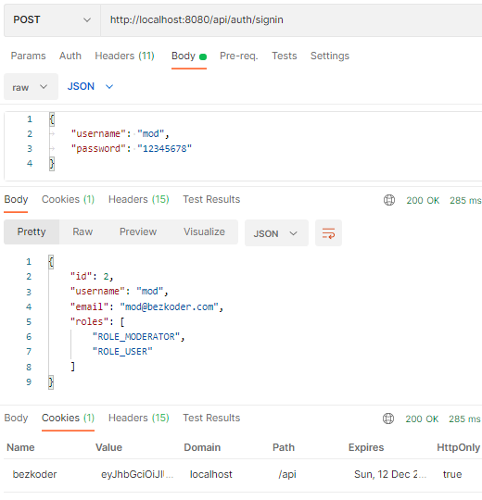

Check the Cookies:

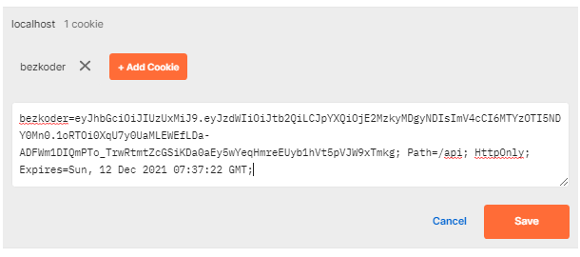

**Access ROLE_USER and ROLE_MODERATOR resource:  
–**GET /api/test/user  
– GET /api/test/mod

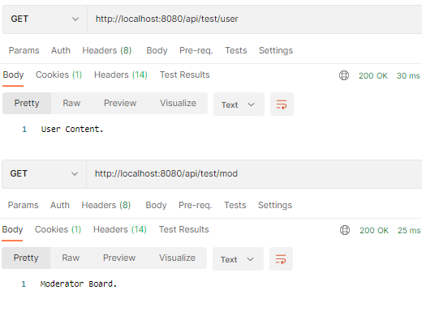

**Access ROLE_ADMIN resource:** GET /api/test/admin

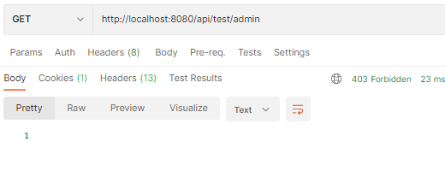

**Logout the Account:**POST /api/auth/signout

